**INTRODUCTION**

The **Rent House Adviser** is an online web-application (Information System) that helps the people trying to buy a rental house in some area they are looking for.

**“Rent-Ad In Brief Rent House Adviser”**

The **Rent-Ad** provides services to people in rent payable and quality better living manner by providing the suitable information like rental price, quality basic facility and number of people living in the house.

In **Rent-Ad** the customer has to register their account information by providing *Proof of Identity* and *other basic information* to identify the customer very clearly.

In **Rent-Ad** the vendors has to register their account and then he can post the rent house descriptions and picture with other information’s that are necessary for our site to be a part of our site.

Registered users can get full benefit of our services and also non-registered users can get our service that is limited in nature.

**OBJECTIVES**

**Objectives of the Project**

Boon Relish is one of the Web-Based Relational Database Management System which will help in making the service easier and save the time of the customer. This will provide the service to the admin and the customer. The admin will have all the rights to do the modification. When the customer logged in then he/she can do the booking of the food item by referring the menu data. The payment can be done by cash, adjust against advance. You can give the feedback about the service and quality of the food items. For the huge orders other than these products contact them for the complete information. By using this application customer can do the orders without any problem.

* To overcome manual work or paper work.
* Online food ordering and Payment.
* Calculation of ingredients to prepare a recipe to avoid the wastage of food.
* Getting the reports according to the date using fuzzy logic.
* To save time.

**TOOLS AND PLATFORMS, HARDWARE AND**

**SOFTWARE REQUIREMENTS**

**Language Tools**

* User Interface Design (Frontend) : HTML 5, CSS 3, Bootstrap 4
* Server Side Scripting : PHP
* Backend : MySQL Server

**Hardware Requirements**

* Processor : Intel Dual Core or any higher version
* Processor Speed : Minimum 1.83 GHz
* RAM : 256 MB of RAM
* Hard Disk : 40 GB or Above

**Software Requirements**

* Language : PHP 5.4,
* Web Components : HTML,
* Database(Backend) : MySQL

**Software Requirement Specification**

**4.1Introduction**

Boon Relish Food Service System is an online food ordering software which will help the customers to book the food online without wasting any time. SRS document of BRFSS which includes the purpose, scope, overview, definitions and abbreviations etc.

**4.1.1 Purpose**

The SRS document of BRFSS is the main objective to provide a base for the foundation of the system. It gives a comprehensive view of how the system is supposed to work. This web based and app based application that can give the accessing permission to the manager and maintaining staff.

By using this online ordering system they can reduce the work load of entering the food items to the billing software. It will give a detailed description of the food items than the previous. Admin can view or get the reports of sales and other expenses. The manager only can view the intelligent operations.

**4.1.2 Scope**

The BRFSS is intended for the food ordering that can be made through online. It will be able to automate the various operations of the BRFSS. The BRFSS will have three end users namely admin, employee and the customer. The system consists of online food booking, SQL server and the report manager. The customer can check the food availability, can do the booking of food item and can pay the bill through online. The admin will have all the rights to modify the rates and he can change the food items day by day.

The main goal of the BRFSS is to simplify everyday process of the BRFSS office. The automation of the system will help the customers to get the information quickly and easy to access. This automation will be able to replace the drawbacks of large customer information case of use and physical files which are difficult to handle. Secure transaction, quick retrieval of information, quick recovery of errors fault tolerance are some of the benefits that development team will be working on to achieve end user satisfaction.

**4.1.3 Definitions, Acronyms and Abbreviations**

**BRFSS** – Boon Relish Food Service System

**RDBMS**  – Relational Database Management System

**WAMP** - Windows Apache MySQL PHP

**OS**  – Operating System

**DFD**  – Data Flow Diagram

**CSS** – Cascading Style Sheet

**HTTP** – Hyper Text Transfer Protocol

**PHP** – Hypertext Pre-processor Personal Home Page

**RAM**  – Random Access Memory

**SQL** – Structured Query Language

**TCP/IP**  – Transfer Control Protocol / Internet Protocol

**HTML**  – Hyper Text Markup Language

**XML** – Extensible Markup Language

**4.1.4 References**

1. An Integrated approach to Software Engineering, 2nd Edition Pankaj Jalote.
2. Fundamentals of Database System, 5th Edition, Elamasri Navathe.
3. PHP, MySQL and Apache, 4th Edition, Meloni

DBMS tutorial: <http://www.w3schools.com/php>

PHP Tutorial: <http://www.php.com>

SQL Tutorial: <http://www.sql.com>

**4.1.5 Overview**

The remaining section of this document describes the overall description which includes the product perspective and the functions and characteristics of users. It also consists of Assumptions and Constraints.

* The second main point will describe about the overall description.
* In third main point specific requirements are described such as external interfaces, user interfaces and hardware and software requirements.
* The forth main point will describe about the functional requirements of the project.

**4.2** **Overall Description**

This main point will describe about the overall description of the project that includes the product functions, constraints and assumptions of the product.

**4.2.1 Product Perspective**

The BRFSS is an open source web based application which helps in making the online food booking. The system mainly consists of three user’s admin, employee and the customer. The developed website runs in all the gadget devices with help of browser. The whole information will be stored in the database which is provided by the user, employee and the admin. They can access the database information in a specific manner. The validation process will be done when the user gives the input to the required fields in the browser by opening the website. The wrong information entered will lead to some problem.

4.**2.2 Product Functions**

The product functions will have more importance in the project.

* The admin and the employee will handle the whole system with different functions.
* Customer Registration will be done at the first to get access over the website and the information provided in that.
* Having a glance at the menu items provided customer can make decision that which items he can order.
* They get a quick view of the products there in the huge database, search option will be provided.
* The customer can order the food items by verifying the availability of food products remaining and the rates of that food product.

**4.2.3 User Characteristics**

In our **Rent House Adviser** project there are mainly three users,

* + Admin (Manager)
  + Employee
  + User
    - Vendor
    - End Service Consumer

**Admin (Manager)**

Admin will have every access to the Rent-Ad Information System. Admin is responsible for managing the resources and the employees. The admin will have the permission to view the reports such as financial, sales, booking information, customer information, response to the feedbacks and others. The manager should have an experience about managing the system.

**Employee**

Employee is the second type of user who maintains the whole system but employee doesn’t have complete access to the system. Employee can manage the order details and the menu items which is to be updated day by day, customer details, booking confirmation, updating the booking details and some of the stocks. The employee should have good communication skill to interact with the customers. Employee should have IT knowledge.

**Customer**

Customers are the vital part of the system. Customer can have the access to view the food menu and the item details and the price and quantity available. Customers will have all the rights to book the food items as well as cancel the order if necessary. Customers will have access to make the online advance payment. Customers will have access to give the feedback about the service and they can have a conversation with the employee.

**4.2.4 General Constraints**

The system will have only 10 GB space of data server. The software must be only in English. Due to limited budget BRFSS is intended to very simple and just for basic functionalities. Application should be based on PHP only. This system is provisioned to be built on the Core PHP which is highly flexible Decision regarding which database to use should be taken considering the fact that the data being exchanged or stored is large, and the appropriate data management system will yield efficient performance. System should sync frequently to backup server in order to avoid the data loss during the failure, so it can be recovered.

**4.2.5 Assumptions and Dependencies**

* It is assumed that the system developed will work perfectly that’s going to be developed under Windows OS, WAMP server with MySQL database.
* In case of any difficulties, SRS should be flexible enough to change accordingly
  1. **Specific Requirements**

This main point consists of the system requirements like interfaces. It gives a description of the system and its features.

* + 1. **External Interface Requirements.**

The External Interface consists of three main parts,

* User Interface
* Hardware Interface
* Software Interface
* Communicational Interface

**4.3.2 User Interface**

The user interface for system shall be compatible to any type of web browser such as Mozilla Firefox, Google Chrome and Internet Explorer.

**4.3.3 Hardware Interface**

In hardware interface it will describe as processor, processor speed, RAM and the Hard disk.

**Server Side**

Processor: Intel Dual Core or any other higher version

Processor Speed: 2 GHz

RAM: 4 GB

Hard Disk: 40 GB and Above

**Client Side**

Processor: Intel Dual Core or any other higher version

Processor Speed: 1.83 GHz

RAM: 256 MB

Hard Disk: 5 GB and Above

**4.3.4 Software Interface**

**Web Server**

* WAMP (Windows Apache MySQL PHP) Server with Windows OS.

**Database Server**

* MySQL Database Server with Windows OS.

**Development End**

* HTML 5, XML, CSS 3, Android UI, PHP 5.4, JAVA

**4.3.5 Communication Interface**

In this web based system communication will be done through TCP / IP protocols.

**4.4 Functional Requirements**

**Logical Modules**

**4.4.1 Registration**

* + - The customer should be able to register with their details.
    - The system should record the following customer details into registration database

1. First name
2. Email-ID
3. Mobile Number
4. Address
5. Password

* The system sends a verification message to Email-ID.

**4.4.2 Logging In**

* + The system should verify the customer Email-ID and the password against the registration database when logging in.
  + After logging in, member will be directed to the home page.

**4.4.3 Menu Data**

* The system should enable customer to check for the food items in the menu.
* The menu will contain the detailed description with of the items like,

1. Item name
2. Unit price
3. Quantity remaining for sale
4. Name in Kannada and English for the reference

* By referring the menu data the customer can do the order.

**4.4.4 Ordering food items**

* Customer can order the food items by selecting them.
* When the customer selects a food item it will display the fields like,
  + - * 1. Item name
        2. Unit Price
        3. Quantity remaining for sale
        4. Ordering date
        5. Quantity required (customer should enter)
        6. Total amount
      * The ordered food items are displayed in a grid view.
      * The system should allow the customer to confirm or cancel the order.
      * The system should record the ordering details into database.

**4.4.5 Payment of Money**

* The system should allow the customer to pay bill via online using debit card.
* The customer can do the advance payment.
  + 1. **Employee Access**
* The system should allow employee to update, add or delete the ordering information.
* The employee will maintain the stocks, menu items etc.
* The system should provide customer desk portal access to employee for providing response to customer inquiry.
  + 1. **Admin Access**
* The system should allow the admin to modify the whole system
* The system should generate the reports of sales and demand forecasting.

**4.5 Performance Requirements**

* Data in database should be updated within 2 seconds.
* Query results must return within 4 seconds.
* Load time of UI should not take more than 3 seconds.
* Login validation should be done within 3 seconds.
* Response to customer inquiry is must be done within 5 minutes.

**4.5.1 Capacity Requirements**

* Not more than 10,000 members to be registered.
* The system need to handle at least 20 transactions during peak hours.

**4.6 Design Constraints**

* This is a RDBMS.
* This application requires internet connection to run.
* Only admin can modify the whole system.
* System will have 10 GB of space of data server.
* Due to the low budget the system is intended to very simple and basic functions.
* System should sync frequently to backup server in order to avoid the loss of data during the failure.

**4.7 System Attributes**

* **Correctness:** This system should satisfy the normal operations of BRFSS to fulfill the end users objectives.
* **Efficiency**: Enough resources to be implemented to achieve the particular task efficiently without any disturbance.
* **Flexibility**: System should be flexible enough to provide space to add new features and so handle them smoothly.
* **Integrity**: System should focus on securing the customer information and avoid the data losses as much as possible.
* **Portability**: The system should run in any Microsoft Windows Environment.
* **Testability**: The system should able to be tested to confirm the performance and customer specification.
* **Maintainability**: The system should be maintainable.
  1. **Other Requirements**

**Security Requirements**

* All external communications between the data’s server and client must be encrypted.
* All the data must be stored, protected or protectively marked.
* The payment process should be secured.

**Safety Requirements**

* Database should be backed up every hour.
* Under failure, system should be able to come back at normal operation under an hour.

**SYSTEM DESIGN**

**5.1 Introduction**

System design is the process of designing architecture, modules, interfaces, and data for a system to satisfy specified requirements. System design contains logical and physical design. Logical designing describe the structure and characteristics or features, like output, input, files, databases and procedures. The physical design which follows the logical design actual software and working system.

**5.2 Overview**

The project BRFSS has minimum three users namely Admin, Employee and the User. In this project system design deals with Context Flow Diagram, Data Flow Diagram and describing the functional components of the system how they are related together. The purpose of designing the system is to present a detailed description of BRFSS.

**5.3 Context Flow Diagram (CFD)**

Context flow diagram is a top level data flow diagram. In CFD the entire system is treated a single process and all its input, output, sinks and source are identified and shown. Here the external entities are like Admin, Employee and the User. Between the process and external entities there are data flows that indicates information exchange between entities and system.

**DFD level 0**

**Vendor**

**Final Service Consumer**

Login Login

**Employee**

**Admin**

Manage details Manage details

Storing Data Retrieve Data

**Data Store**

**5.4 Data Flow Diagram**

Data Flow Diagram is a graphical representation of system. It consists of data 1flows, process, sources and sinks and stores all the description through the use of symbols. DFD is also shows the information moves through and how it is modified by a series of transformation. It is a graphical technique that depicts information moves from input or output.

**DFD Symbols:**

|  |  |  |
| --- | --- | --- |
| **Name** | **Notation** | **Description** |
| **Process** |  | A process transforms incoming data flow into outgoing data flow. A process is showed by named circles. |
| **Data Store** | **or** | Data stores are repositories of data in the system. They are sometimes also referred to as files. |
| **Data Flow** |  | Data flows are pipeline through which packet of information flow. Label the arrows with the name of the data that moves through it. |
| **External Entity** |  | External Entities are objects outside the system, with which the system communicates. External Entities are the sources and the destinations of the system’s input and output. |

**DFD LEVEL 1**

**Properties**

**Employee**

**Properties**

**Properties**

**Employee**

**Employee**

**Employee**

**Employee**

**Properties**

**Properties**

**DFD LEVEL 1**

a_id, u_id, name, email u_id

**USER**

Address, password user details

a_id, e_id, name, email e_id

**EMPLOYEE**

Photo, adhar, experience employee details

a_id, m_id, i_name m_id

**MENU**

Category, unitprice menu_details

s_id, a_id, s_category s_id

**ADMIN**

**STOCKS**

Date, vendor stock_details

a_id, o_id, o_number o_id

category, name, total **ORDERS**

Order_details

a_id, c_id, code c_id

**COUPONS** c_validitycoupon_details

f_id, a_id, email, name f_id

**FEEDBACK**

messagefeedback

details

**DFD LEVEL 1**

e_id, u_id, name u_id

**REGISTER**

Email, passworduser_details

e_id, m_id m_id

category, price **MENU**

Menu_details

o_id,e_id o_id

**CUSTOMER**

o_num, total **ORDER**

Order_details

f_id, e_id f_id

**FEEDBACK**

Name, message Feedback

details

e_id, p_id p_id

**PAYMENT**

Card_no, exp_year, cvc Payment

deails

**5.5 DFD LEVEL 2**

menu_id

**MENU**

menu_details

menu_id menu_details

o_id

**CUSTOMER**

**ORDER**

order_details

p_id

**PAYMENT**

Payment_details

f_id

**FEEDBACK**

Feedback

**DFD level 2**

M_id, name

MENU

Menu_details

f_id

food_details

**Customer Food Order**

o_id, o_num

ORDER

order_details

p_id, card

Payment

payment_details

5.6 Entity Relationship Diagram

Entity Relationship Diagram describes inters related things of internet in a specific domain of knowledge. An ER-Diagram is composed of entity types and specifies the relationship that can exist between instances of those entities. An entity represents an object defined within the information system about which you want to store information.

ER-Diagram Symbols:

|  |  |  |
| --- | --- | --- |
| Name | Notation | Description |
| Entity |  | It may be an object with physical existence or conceptual existence. |
| Attribute |  | The properties of entity can be attribute. It is represented by ellipse. |
| Relationship |  | Whenever an attribute of one entity refers to another entity, some relations exists. |
| Link |  | Lines link attribute to entity sets an entity sets relation |
| Derived Attribute |  | Dashed ellipse denotes derived attribute |
| Key Attribute |  | An entity type usually has an attribute whose values are distinct for each individual entry in the entity set. |
| Multivalued Attribute |  | Attributes have different number of values for a particular attribute. |
| Cardinality Ratio | 1:1  1:M  M:1  M:M | It specifies the maximum number of relationships, instance that an entity can participate in. |

1 M

**Admin**

**Feedback**

checks

1

1 1 1 M

Manage

**Stocks**

Manages

**Customer**

**Employee**

Manages

M

M M 1

Manages

M

1 1 1 1

**Menu Items**

upload

M M

views

generate

M

order

has

**Coupons**

check

M

M M

**Food Items**

**Orders**

**DATABASE DESIGN**

**6.1 Introduction**

Database design gives an idea about database structure of the software. A database is an inherit collection of data with some inherit meaning, designing, built and populated with data for the specific purpose. Database description describes all the databases used in the software to store all the records. Because of creating database, it will reduce the manual work. It will give the flexibility in the data storage and retrieval of data and production of information.

This system is also does the required calculations, maintains error free reports and validates the final report within a short period of time. It determines what type of data is needed and how they are processed. OS of computer is responsible for placing the data on the storage devices.

1. **Admin and User Login**

|  |  |  |  |
| --- | --- | --- | --- |
| a_id | Int | Primary Key | Admin ID |
| Username | Varchar | Not Null | User Name |
| Password | Varchar | Not Null | Password |

1. **Employee**

|  |  |  |  |
| --- | --- | --- | --- |
| e_id | Int | Primary key | Employee ID |
| e_name | Varchar | Not Null | Name |
| e_phone | Bigint | Not Null | Phone |
| e_addr | Varchar | Not Null | Address |
| e_gender | Text | Not Null | Gender |
| e_email | Varchar | Not Null | Email-ID |
| e_doj | Date | Not Null | Date of Join |
| e_experience | Varchar | Not Null | Experience |
| e_photo | Varchar | Not Null | Image |
| e_adhar | Bigint | Not Null | Adhar Number |
| e_password | Varchar | Not Null | Password |
| a_id | Int | Foreign Key | Admin ID |

1. **User**

|  |  |  |  |
| --- | --- | --- | --- |
| u_id | Int | Primary Key | User ID |
| Name | Varchar | Not Null | Name |
| Gender | Text | Not Null | Gender |
| Phone | Bigint | Not Null | Phone Number |
| Address | Varchar | Not Null | Address |
| Email | Varchar | Not Null | Email-ID |
| Password | Varchar | Not Null | Password |
| e_id | Int | Foreign Key | Employee ID |

1. **Menu Item**

|  |  |  |  |
| --- | --- | --- | --- |
| i_id | Int | Primary Key | Item ID |
| i_category | Varchar | Not Null | Item Category |
| i_name | Varchar | Not Null | Item Name |
| i_subtitle | Varchar | Not Null | Item Subtitle |
| i_image | Varchar | Not Null | Item Image |
| i_unitprice | Bigint | Not Null | Item Unit Price |
| i_prepared | Bigint | Not Null | Item Prepared |
| i_discount | Bigint | Not Null | Discount Rate |
| e_id | Int | Foreign Key | Employee ID |

1. **Order Table**

|  |  |  |  |
| --- | --- | --- | --- |
| o_id | Int | Primary Key | Order ID |
| o_date | Date | Not Null | Order Date |
| c_id | Int | Foreign Key | Coupon ID |
| o_number | Bigint | Not Null | Order Number |
| u_id | Int | Foreign Key | User ID |
| item_category | Varchar | Not Null | Category |
| i_name | Varchar | Not Null | Item Name |
| i_unitprice | Bigint | Not Null | Unit Price |
| qty_remaining | Bigint | Not Null | Quantity Remaining |
| req_quant | Bigint | Not Null | Required Quantity |
| total_price | Bigint | Not Null | Total Price |
| e_id | Int | Foreign Key | Employee ID |

1. **Coupon Table**

|  |  |  |  |
| --- | --- | --- | --- |
| c_id | int | Primary Key | Coupon ID |
| c_title | Varchar | Not Null | Coupon Title |
| c_code | Varchar | Not Null | Coupon Code |
| c_discount | Bigint | Not Null | Discount |
| c_createddate | timestamp | Not Null | Created Table |
| c_validity | timestamp | Not Null | Validity |
| e_id | Int | Foreign Key | Employee ID |

1. **Food Items**

|  |  |  |  |
| --- | --- | --- | --- |
| f_id | Int | Primary Key | Food ID |
| f_name | Varchar | Not Null | Food Name |
| f_category | Varchar | Not Null | Category |
| f_discount | Bigint | Not Null | Discount |
| f_image | Varchar | Not Null | Image |
| f_price | Bigint | Not Null | Price |
| e_id | Int | Foreign Key | Employee ID |

1. **Stocks Table**

|  |  |  |  |
| --- | --- | --- | --- |
| s_id | Int | Primary Key | Stock ID |
| s_category | Varchar | Not Null | Category |
| s_name | Varchar | Not Null | Stock Name |
| s_quantity | Bigint | Not Null | Quantity |
| s_receiveddate | Date | Not Null | Received Date |
| s_vendor | Varchar | Not Null | Vendor Name |
| e_id | Int | Foreign Key | Employee ID |

1. **Feedback Table**

|  |  |  |  |
| --- | --- | --- | --- |
| f_id | Int | Primary Key | Feedback ID |
| u_id | Int | Foreign Key | User ID |
| i_id | Int | Foreign Key | Item Name |
| f_date | Date | Not Null | Feedback Date |
| f_title | Varchar | Not Null | Title |
| f_description | Varchar | Not Null | Description |
| a_id | Int | Foreign Key | Admin ID |

**DETAILED DESIGN**

**7.1 Introduction**

Detailed design is the phase where the design is refined and plans, specifications and estimates are created. Detailed design will include outputs. The detailed design has strong impact on the overall project. Detailed design consists of structured English and pseudo codes which are some of the important parts of the detailed design.

Major modules of the system are,

1. Login Module.
2. Register Module
3. Stock Module
4. Order Module
5. Payment Module
6. Recipe Calculator Module
7. Feedback Module
8. **Login Module**

BEGIN

User enters the username (email id).

User enters the password.

Check both username and password in MySQL Database.

IF both username and password is correct THEN

Directly enter into the home page of the website.

ELSE IF both username and password is correct THEN

Both username and password are incorrect.

END

1. **Register Module**

BEGIN

User enters the name.

User enter the Phone number

IF phone number is less than 10 digits THEN

PRINT incorrect Phone number

ELSE

Go to next field.

User enters the Email- ID.

IF Email-ID is not in the format THEN

PRINT invalid Email-ID.

ELSE

Go to next field.

User enters address in detail.

User enter password.

(These fields are stored in MySQL database, Email-ID and Password will be used for customer login)

END

1. **Stock Module**

BEGIN

IF Employee added the product THEN

Product successfully added.

ELSE IF Employee want to delete the product THEN

IF Employee added the product THEN

Product is deleted.

ELSE

Product cannot be deleted

ELSE IF Employee want to edit the product details THEN

IF Employee added the product THEN

Product is updated

ELSE

Product cannot be updated

END

1. **Order Module**

BEGIN

IF user want to order the food item THEN

Open the ordering form to fill in

ELSE

Does not open the form

IF entered item is not present THEN

Food ordering cannot be done

ELSE

You can ordering can be done

IF entered item isn’t available when ordering time is over THEN

You have to choose another item

ELSE

You can order the food item

IF the ordered quantity is greater than the remaining quantity THEN

Enter the valid required quantity

ELSE

You can order the food item below the remaining quantity

IF order date is older than the system date THEN

Please enter the valid date

ELSE

You can enter the next date of the food order

IF coupon code is there for food order for a food item THEN

You can get discount over the food item

ELSE

Coupon is not valid

END

1. **Payment Module**

BEGIN

IF order is confirmed THEN

Pay bill via cash, advance payment or online payment

ELSE

You can order the food and confirm the order

IF the payment method is cash THEN

Customer should pay the bill manually

ELSE

Customer can’t pay the bill when order is not confirmed

IF the payment method is Advance Payment THEN

Customer should pay the bill manually (counted via points)

ELSE

Customer can’t pay the bill when order is not confirmed

IF the payment method is online payment THEN

Customer should pay the bill via debit card

IF card number is not correct THEN

Print card number is not correct

ELSE

Show the card type and proceed

IF expiry date is not correct THEN

Enter the proper expiry date

ELSE

Proceed to next field

Enter the proper CVV number

ELSE

Customer can’t pay bill, when order is not confirmed

END

1. **Recipe Calculator**

BEGIN

IF admin want the recipe description THEN

Enter the quantity required of food item

ELSE

Only the format will be displayed

IF admin wants to know the requirement for preparing the food item THEN

It will display the food items required to prepare the food item with required quantity

ELSE

Entered item is not present

END

1. **Feedback Module**

BEGIN

IF the customer wants to give the feedback THEN

Enter the feedback button

ELSE

Customer can contact them

IF Customer enter the feedbacks about the food items THEN

Customer should select the food item

ELSE

Please select the food item you want to give the feedback

User enters the Name

User enters the Email-ID

User enters the mobile number

User gives a description of message (feedback)

Enter the Send button

End

**TESTING**

**9.1 INTRODUCTION**

Testing is the most important phase in the Software Development Activity Software Development life cycle (SDLC) the main aim of the testing process in the quality, the developed Software in tested against the required functionality and performance.

During the testing process the software is worked with some particular test case and the output of the test cases are analyzed whether the software is working ascending to the expectation or not.

**TYPES OF TESTING**

The two basic approaches are:

* Black Box or Function Testing
* White Box or Structural Testing
* **Black Back or Function Testing:**

Black Box testing treats the software as a “black box”, examining functionality without any knowledge internal implementation, without seeing the source code. Specification-based testing may be necessary to assure correct functionality, but is insufficient to guard against complex or high-risk situations. Test cases are built around specifications and requirement, i.e., what the application is supposed to do. It uses external descriptions of the software, including specifications, requirements and designs to derive test cases. These tests can be functional or non-functional, though usually functional.

* **White Box or Structural Testing:**

White box testing(also known as glass box testing, transparent box testing and structural testing, by seeing the source code) tests internal structures or workings of a program, as opposed to the functionality exposed to the end-user. In White box testing, an internal perspective of the system, as well as programming skills, is used to design test cases. The tester chooses inputs to exercise paths through the code and determine the appropriate outputs this is analogous to testing nodes in a circuit, e.g. in-circuit testing (ICT).

* **LEVELS OF TESTING**

Since the error in the software can be injured at any stage. So we have carry in the testing process at different levels during the development. The basic levels of testing are

* Unit Testing
* Integration Testing
* System Testing
* Acceptance Testing
* **UNIT TESTING:**

Unit testing is performed to test the individual units of software. Since software is made of a number of units/modules, detecting errors in these units is simple and consume less time, as they are small in size. However it is possible that the outputs produced by one unit become input for another unit. Hence, if incorrect output produced by one unit is provided as input to the second unit, then it also produces wrong output. If this process is not corrected, the entire software may produce unexpected outputs. To avoid this, all the units in software are tested independently using unit testing.

Unit testing is not just performed once during the software development, rather it is repeated whenever software is modified or used in a new environment.

* **INTEGRATION TESTING:**

Integration testing is to ensure that all the modules continue to work in accordance with user/customer requirements even after integration. Integration testing is a systematic for constructing the program structure, while at the same time conducting tests to uncover error associated with interfacing.

The objective of integration testing is to take all the tested individual modules, integrate them, test them again and develop the software, which is according to design specification. The other points that are noted about integration testing are listed below.

* **SYSTEM TESTING**

Software is integrated with other elements, such as hardware, people and database to form a computer-based system. This system is then checked for error using system testing. System testing compares the system with the non-function system requirements, such as security, speed, accuracy and reliability. The emphasis is on validating and verifying the functional design specifications and examining how modules work together. This testing also evaluates external interfaces to other application and utilities or the operating environment.

* **ACCEPTANCE TESTING**

Acceptance testing is the process of testing the system with real data information, which the system is intended to manipulate. User acceptance of a system is the key factor for the success of any system. The system under consideration was tested for user acceptance by constantly keeping in which with the perspective system users at the time of developing and making changes wherever required.

**TEST CASES:**

**Login Page:**

|  |  |  |  |  |
| --- | --- | --- | --- | --- |
| **Sl.No** | **Test Description** | **Test Case Data** | **Expected Output** | **Result** |
| 1 | Username and  Password are correct | Click on Login. | Directs to the respected Home Pages. | SUCCESS |
| 2 | Password left blank | Click on Login. | Message-Enter the Password. | SUCCESS |
| 3 | Both Username and Password are wrong | Click on Login. | Message-Invalid Username/Password | SUCCESS |

**User Registration Page:**

|  |  |  |  |  |
| --- | --- | --- | --- | --- |
| **Sl.No** | **Test Description** | **Test Case Data** | **Expected Output** | **Result** |
| 1 | If the Name field is left blank. | Click on Submit | Message-This field is required | SUCCESS |
| 2 | If the Email-ID field is left blank. | Click on Submit | Message-This field is required | SUCCESS |
| 3 | If the Address field is left blank. | Click on Submit | Message-This field is required | SUCCESS |
| 4 | If the phone number field is left blank. | Click on Submit | Message-Phone number is required | SUCCESS |
| 5 | Valid all the field | Click on Submit | Message- directs to home page | SUCCESS |

**Order Page:**

|  |  |  |  |  |
| --- | --- | --- | --- | --- |
| **Sl.No** | **Test Description** | **Test Case Data** | **Expected Output** | **Result** |
| 1 | If the Name field is left blank. | Click on Submit | Message-This field is required | SUCCESS |
| 2 | If the Date field is left blank. | Click on Submit | Message-This field is required | SUCCESS |
| 3 | If the Category field is left blank. | Click on Submit | Message-This field is required | SUCCESS |
| 4 | If the Food item field is left blank. | Click on Submit | Message-This field is required | SUCCESS |
| 5 | If the Required quantity field left blank | Click on Submit | Message-This field is required | SUCCESS |
| 6 | If all fields are correct | Click on add on Next Item | Message- Order added | SUCCESS |

**Payment Page:**

|  |  |  |  |  |
| --- | --- | --- | --- | --- |
| **Sl.No** | **Test Description** | **Test Case Data** | **Expected Output** | **Result** |
| 1 | If the Name on card field is left blank. | Click on Pay | Message-This field is required | SUCCESS |
| 2 | If the Card number field is left blank. | Click on Pay | Message-This field is required | SUCCESS |
| 3 | If the card number is less than 16 numbers. | Click on Pay | Message-card number required of 16 digits | SUCCESS |
| 4 | If Expiry month not entered. | Click on Pay | Message-This field is required | SUCCESS |
| 5 | If Expiry year is not entered. | Click on pay | Message-This field is required | SUCCESS |
| 6 | If CVV number field left blank. | Click on pay | Message- This field is required | SUCCESS |
| 7 | All values are valid | Click on pay | Message- directs to next page | SUCCESS |

**Add Employee:**

|  |  |  |  |  |
| --- | --- | --- | --- | --- |
| **Sl.No** | **Test Description** | **Test Case Data** | **Expected Output** | **Result** |
| 1 | If the employee name field is left blank. | Click on Add | Message- This field is required | SUCCESS |
| 2 | If the Mobile number is left blank. | Click on Add | Message- This field is required | SUCCESS |
| 3 | If the Email field is left blank. | Click on Add | Message-Email is required | SUCCESS |
| 4 | If Date of join field left blank. | Click on Add | Message- This field is required | SUCCESS |
| 5 | If Year of experience field left blank. | Click on Add | Message- This field is required | SUCCESS |
| 6 | If Adhar ID field left blank. | Click on Add | Message- This field is required | SUCCESS |
| 7 | If all fields are correct. | Click on Add | Message: Successfully Added | SUCCESS |

**Add Recipe:**

|  |  |  |  |  |
| --- | --- | --- | --- | --- |
| **Sl.No** | **Test Description** | **Test Case Data** | **Expected Output** | **Result** |
| 1 | If the food item field is left blank. | Click on Submit | Message- This field is required | SUCCESS |
| 2 | If the description for preparation is left blank. | Click on Submit | Message- This field is required | SUCCESS |
| 3 | If the Ingredients field is left blank. | Click on Submit | Message-This field is required | SUCCESS |
| 4 | If Quantity field left blank. | Click on Submit | Message- This field is required | SUCCESS |
| 5 | If measuring terms field left blank. | Click on Submit | Message- This field is required | SUCCESS |
| 7 | If all fields are correct. | Click on Submit | Message: Directs to next page. | SUCCESS |

**Recipe calculator:**

|  |  |  |  |  |
| --- | --- | --- | --- | --- |
| **Sl.No** | **Test Description** | **Test Case Data** | **Expected Output** | **Result** |
| 1 | If all the fields are filled correctly | Click on Calculate. | Message - Calculation of ingredients displayed. | SUCCESS |
| 2 | Food item left blank | Click on Calculate. | Message – This field is required. | SUCCESS |
| 3 | If quantity left blank | Click on Calculate. | Message – This field is required. | SUCCESS |

**Add Coupon:**

|  |  |  |  |  |
| --- | --- | --- | --- | --- |
| **Sl.No** | **Test Description** | **Test Case Data** | **Expected Output** | **Result** |
| 1 | If the Coupon Title field is left blank. | Click on Add | Message- This field is required | SUCCESS |
| 2 | If the Coupon code field left blank. | Click on Add | Message- This field is required | SUCCESS |
| 3 | If the Coupon discount field is left blank. | Click on Add | Message-This field is required | SUCCESS |
| 4 | If the created date field left blank. | Click on Add | Message- This field is required | SUCCESS |
| 5 | If the validity date field left blank. | Click on Add | Message-This field is required | SUCCESS |
| 7 | If all fields are correct. | Click on Add | Message-Directs to next page. | SUCCESS |

INPUT AND OUTPUT PAGE SCREEN SHOTS

**Login Page:**

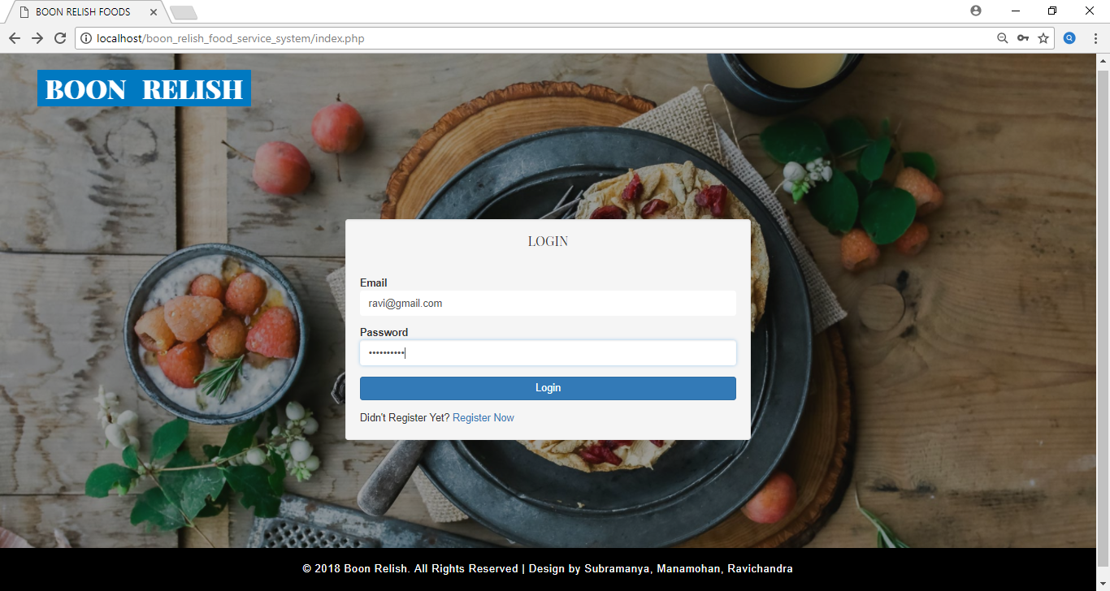

**User Registration Page:**

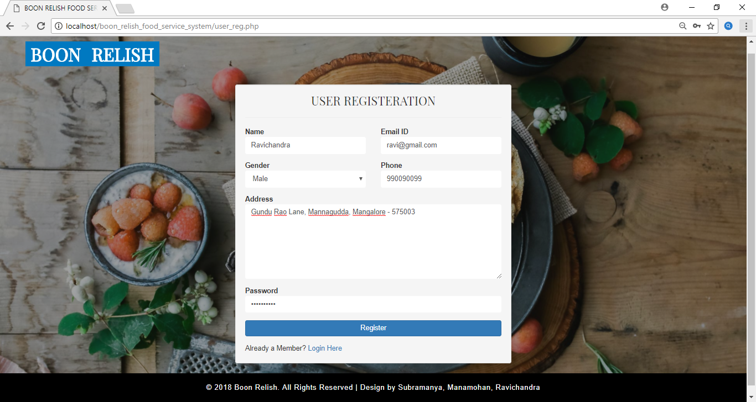

**Home Page**:

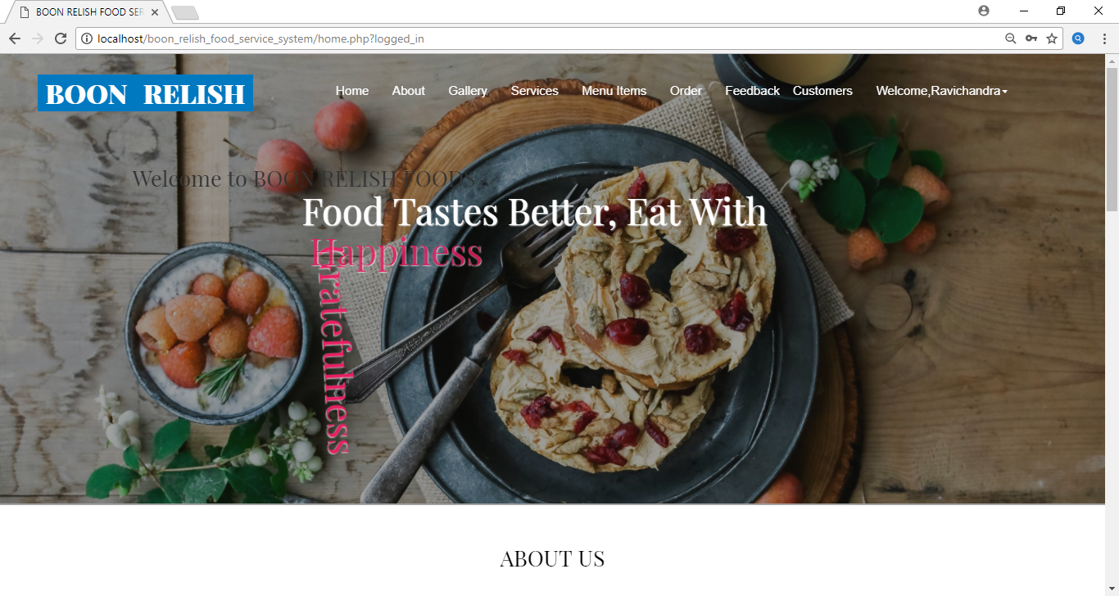

**Gallery:**

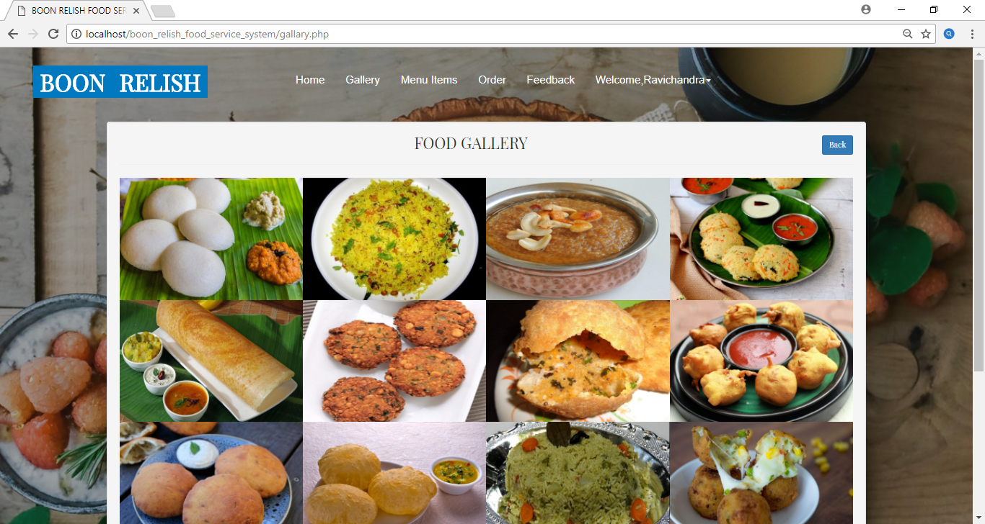

**Menu Items:**

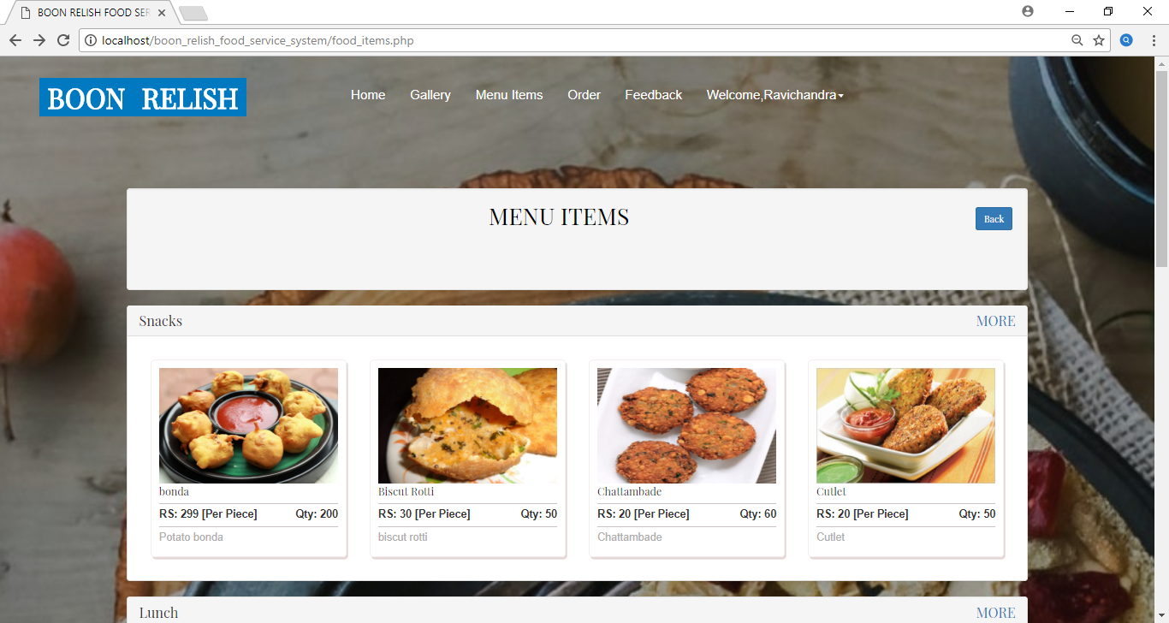

Order Form:

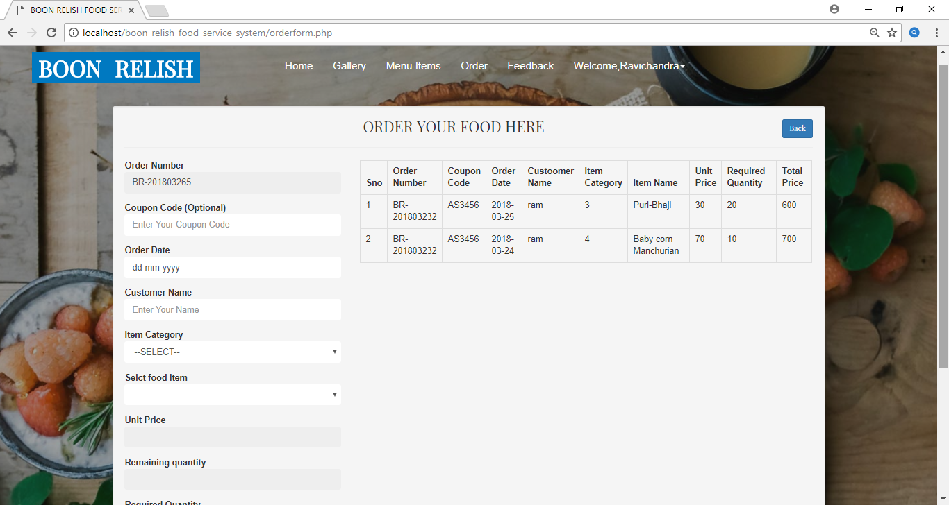

**Payment:**

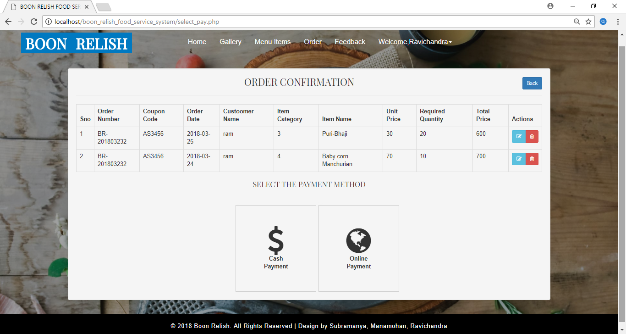

**Online Payment(Debit card):**

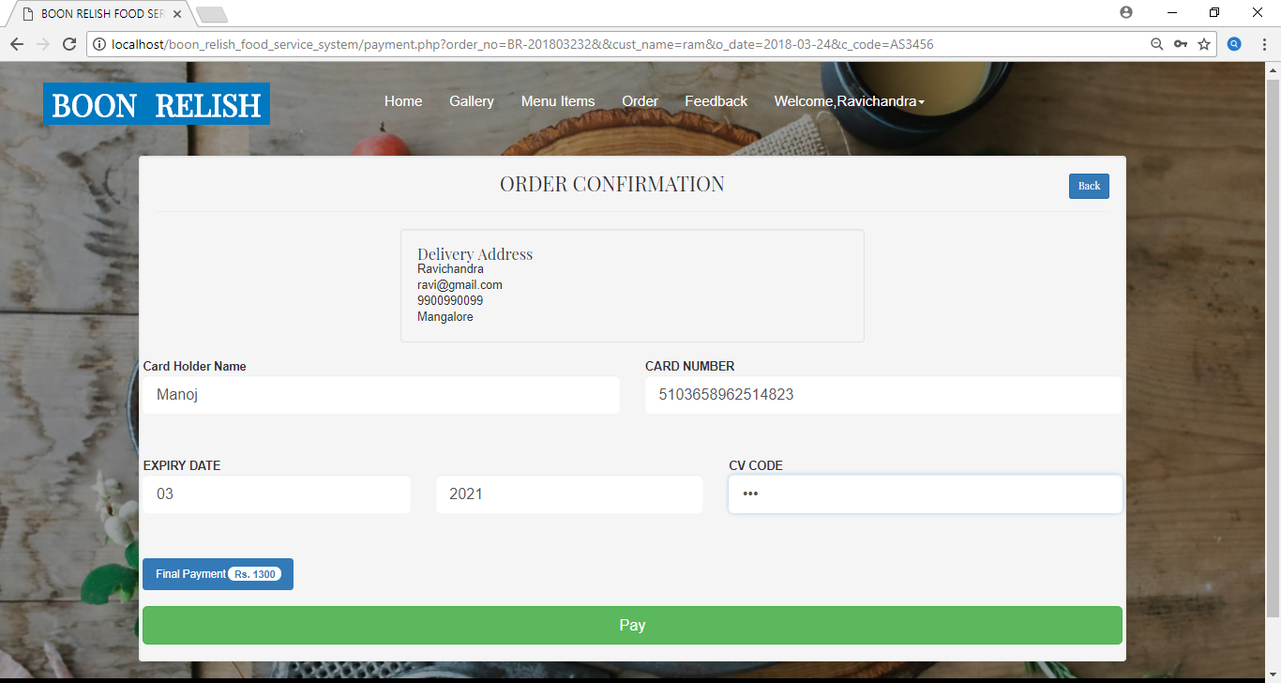

**Bill Invoice:**

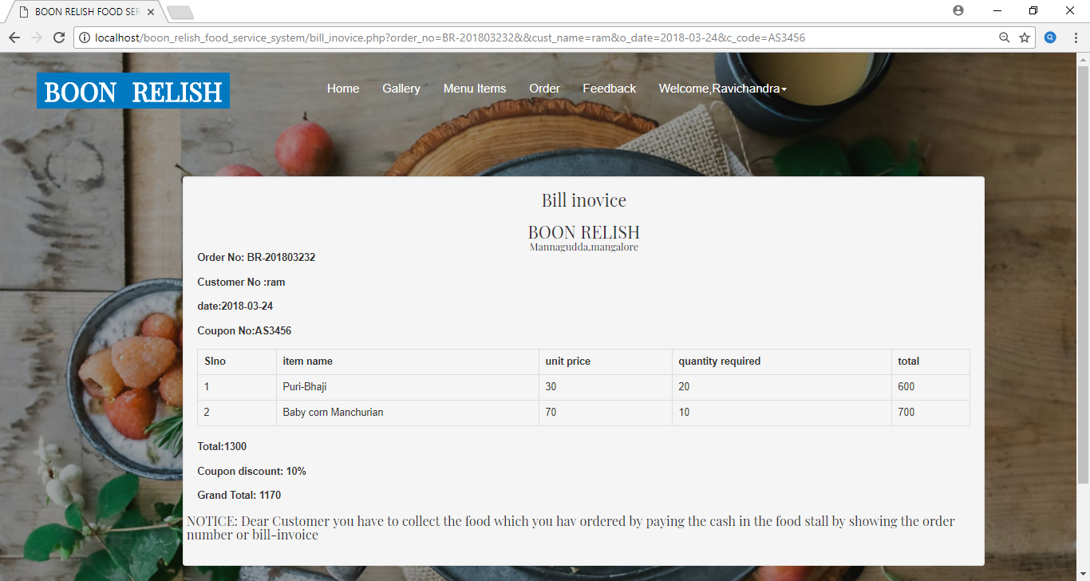

**Customer Feedback:**

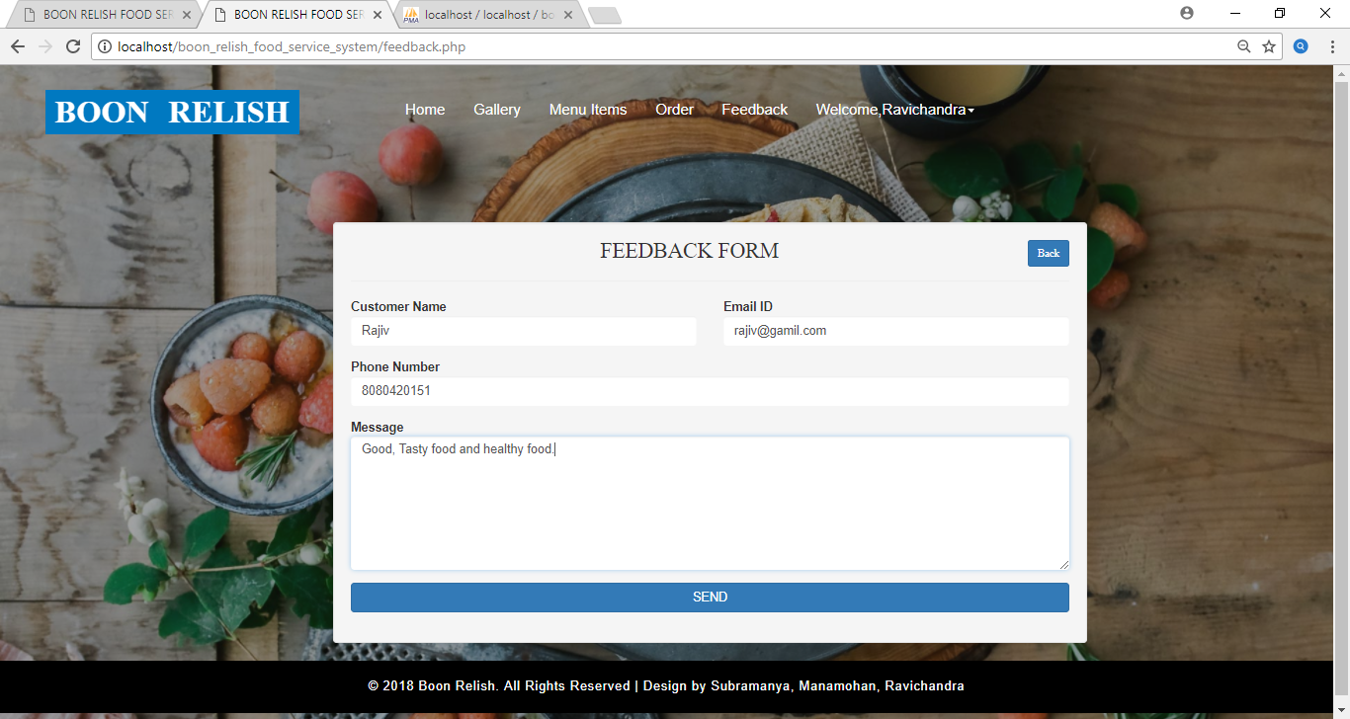

**Admin and Employee Login:**

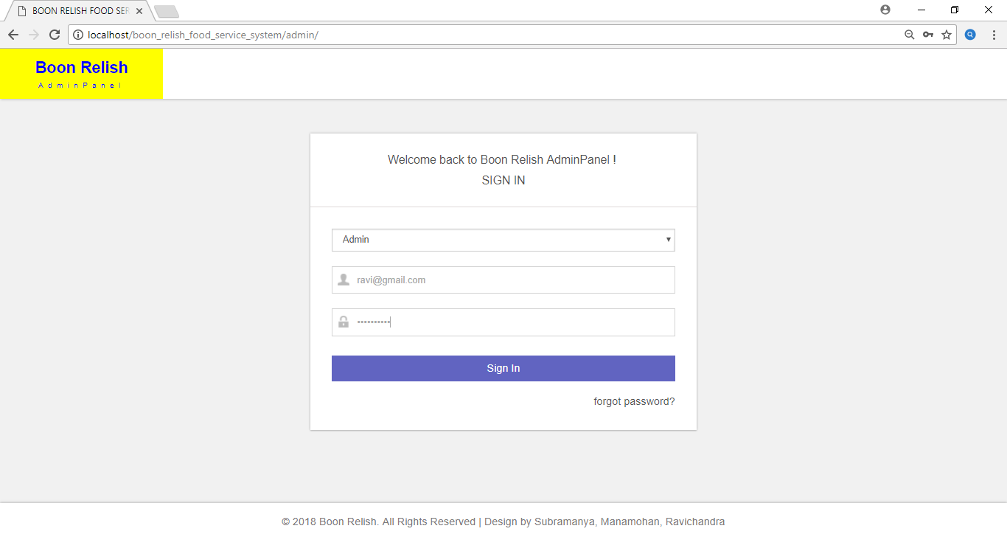

**Add Items:**

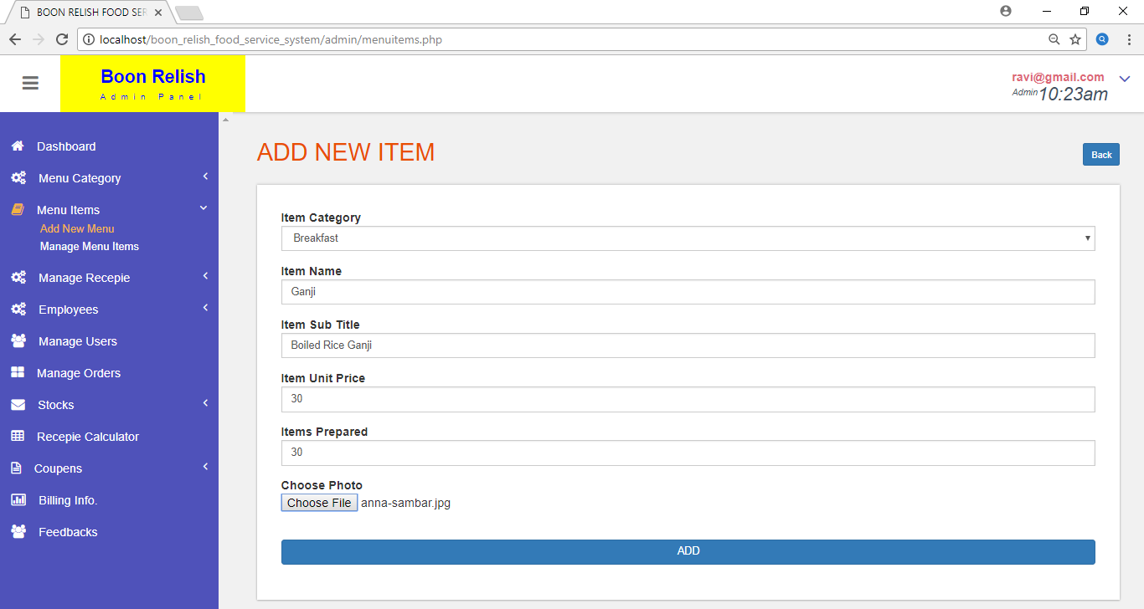

**Manage Items:**

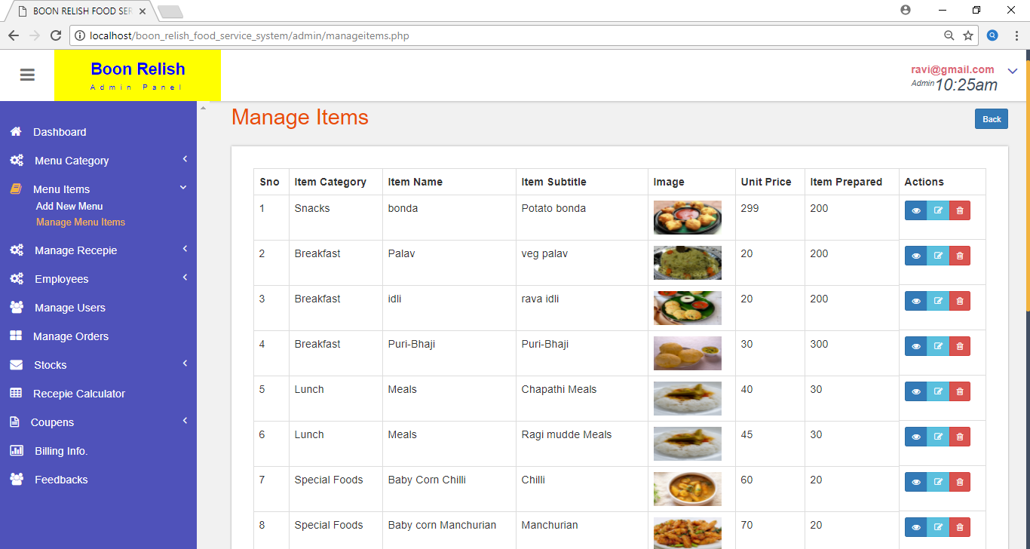

**Add Employee:**

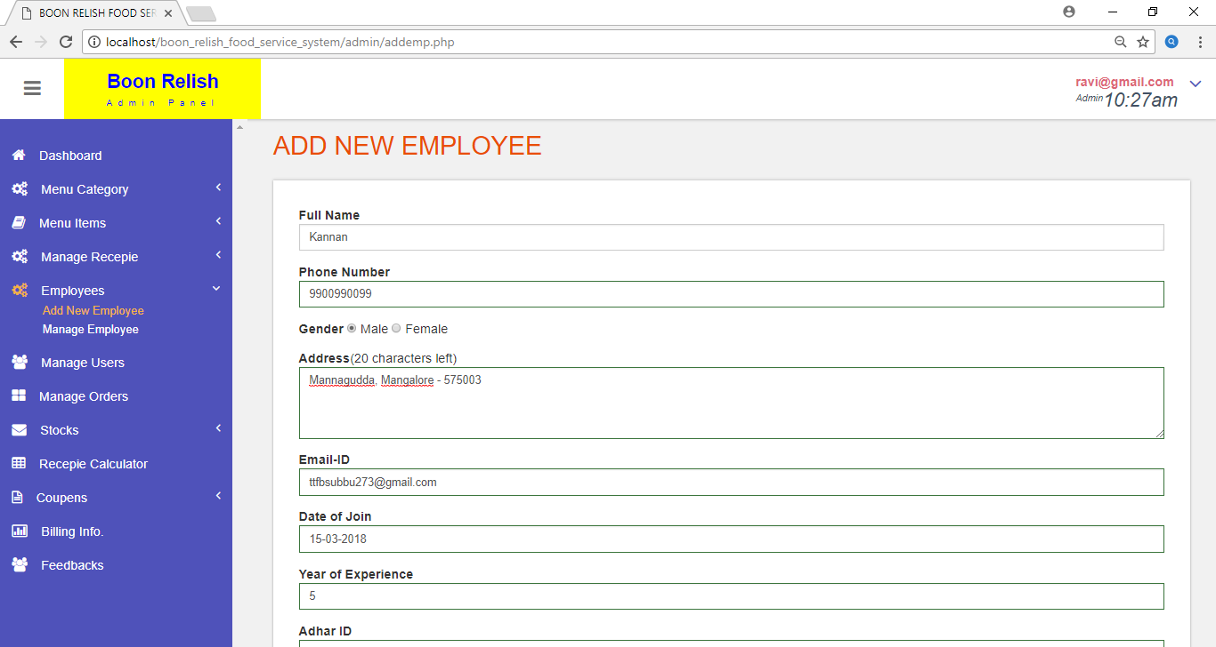

**Manage Employee:**

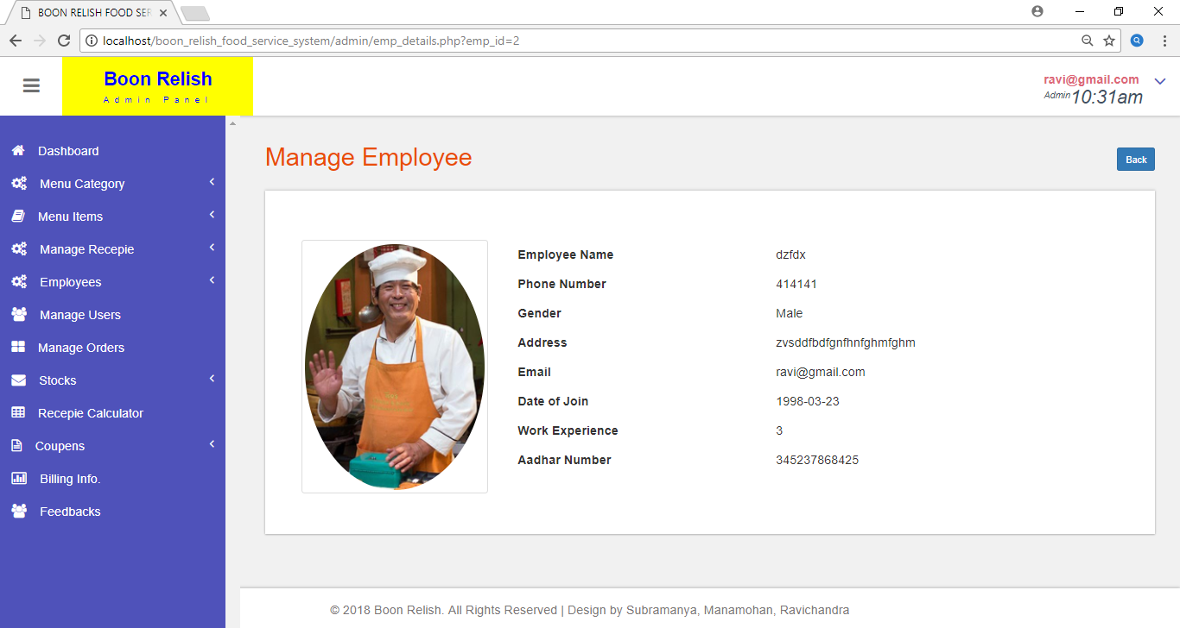

**Add Recipe:**

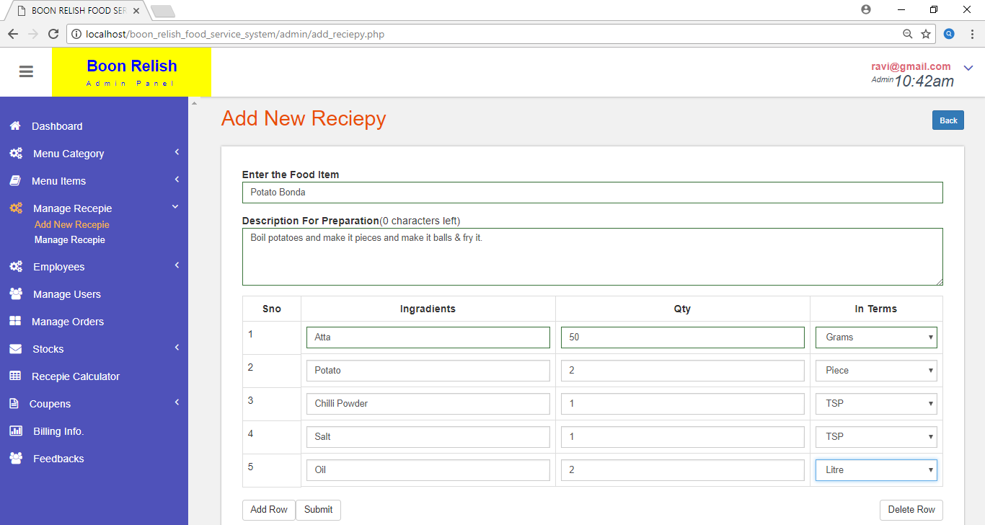

**Recipe Calculator:**

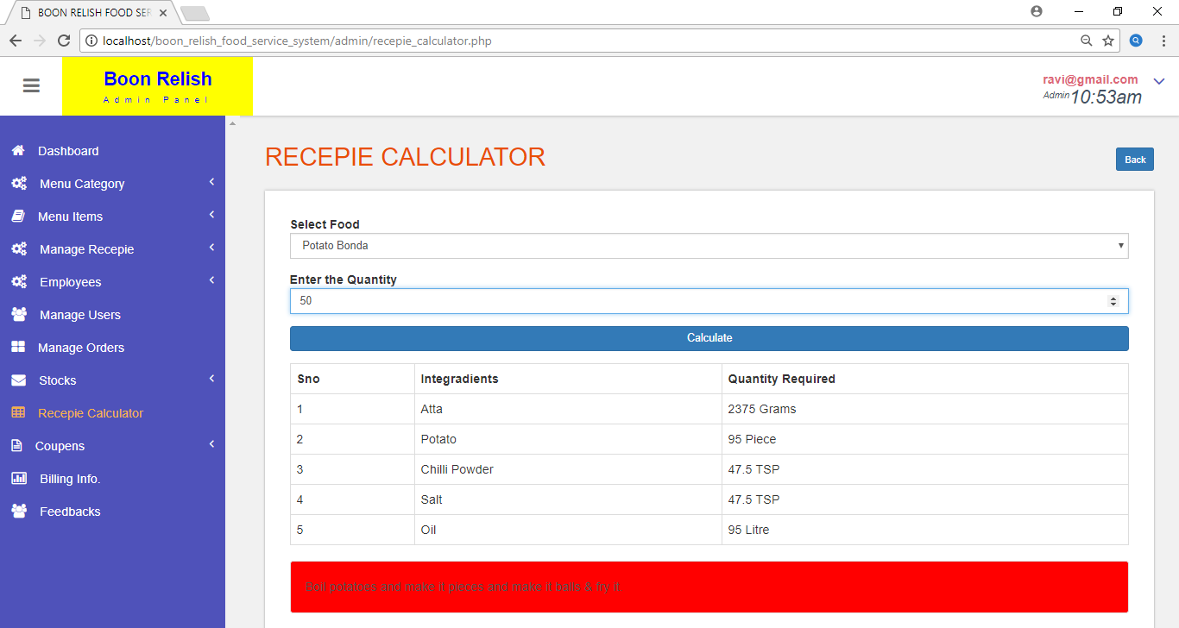

**Manage Users:**

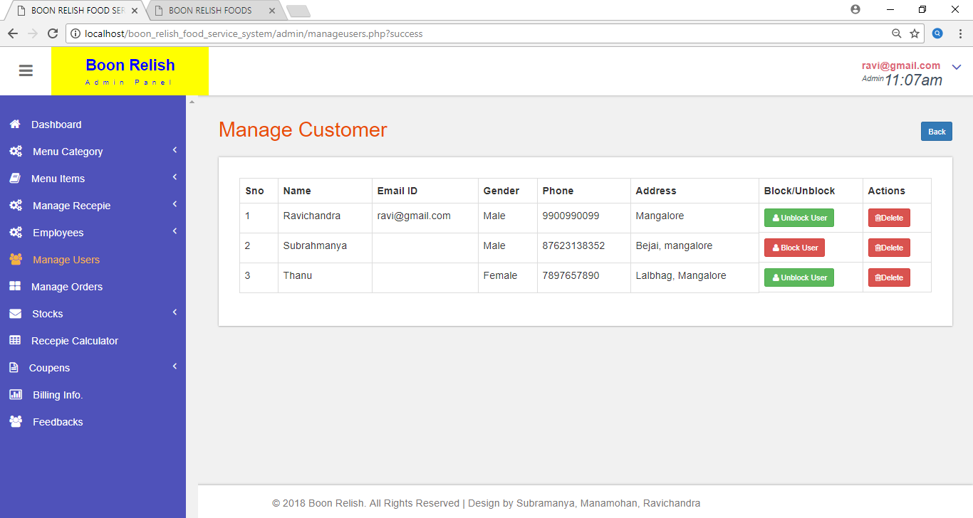

**LIMITATIONS**

**Limitations of the Project**

* Without proper registration of the customer food order servicing cannot be carried out.
* Without proper details of the bank, Advance payment and online payment cannot be carried out.
* This system is only reserved for the client Boon Relish.
* Without Internet connection your application will not work.

**FUTURE SCOPE**

* All the customers can further use this system and this can be integrated with mobile application also developed for all the other services so that the customers find very easy to order the food.
* They can make the advance payment through internet.
* The system can have the home delivery options and quality of food to server better and get more number of customers in further enhancement.

**Conclusion**

The project “BOON RELISH” was successfully tested and implemented under various platforms of Windows 7 and above. The system developed has proved to be use friendly and efficient in achieving basic goals. The system takes care of all the constraints which have specified. The system is found to be very beneficial for the concerned aspects. Application developed is realistic and secure.

The main idea is to develop an easy front end using concept of HTML, XML, CSS 3, PHP and JAVA Script. All the possible user requests are accomplished in a very good manner. All the validations have been done.

**BIBILOGRAPHY**

**References**

<http://www.w3schools.com/php>

<http://www.php.com>

<http://www.sql.com>

Complete Project Source can be found at GitHub

<https://www.github.com/Darshan20J/rent-ad>

**Books**

* An Integrated approach to Software Engineering, 2nd Edition, Pankaj Jalote
* Fundamentals of Database System, 5th Edition, Elamasri Navathe.
* PHP, MySQL and Apache, 4th Edition, Meloni